PRACTICAL LIST – AY: 2026- 27
Sr. no. | Title
5. | Title: Bug Tracking and Defect Management using Jira  Aim: To understand the software defect lifecycle by creating, assigning, tracking, and resolving software bugs using Jira.  Software/Tools Required  - Jira Cloud  - Web Browser  - Internet Connection  Procedure  - Create a Jira account and log in.  - Create a Software Testing project.  - Create a new Bug issue.  - Enter bug details such as summary, description, severity, and priority.  - Assign the bug to a developer.  - Update the bug status through different stages (To Do → In Progress → Done).  - Verify the resolved bug and close the issue.  - Record the observations.  Expected Outcome: Students understand the complete defect management process using an industry-standard bug tracking tool.  Result: The software defect lifecycle was successfully managed using Jira

Step 1: Create a Bug Tracking Project
Log in to Jira and create a dedicated Bug Tracking project.
- Open Jira.
- Click Projects → Create Project.
- Select Software Development → Bug Tracking.
- Click Use Template.
- Enter Project Name and Project Key.
- Click Create Project.

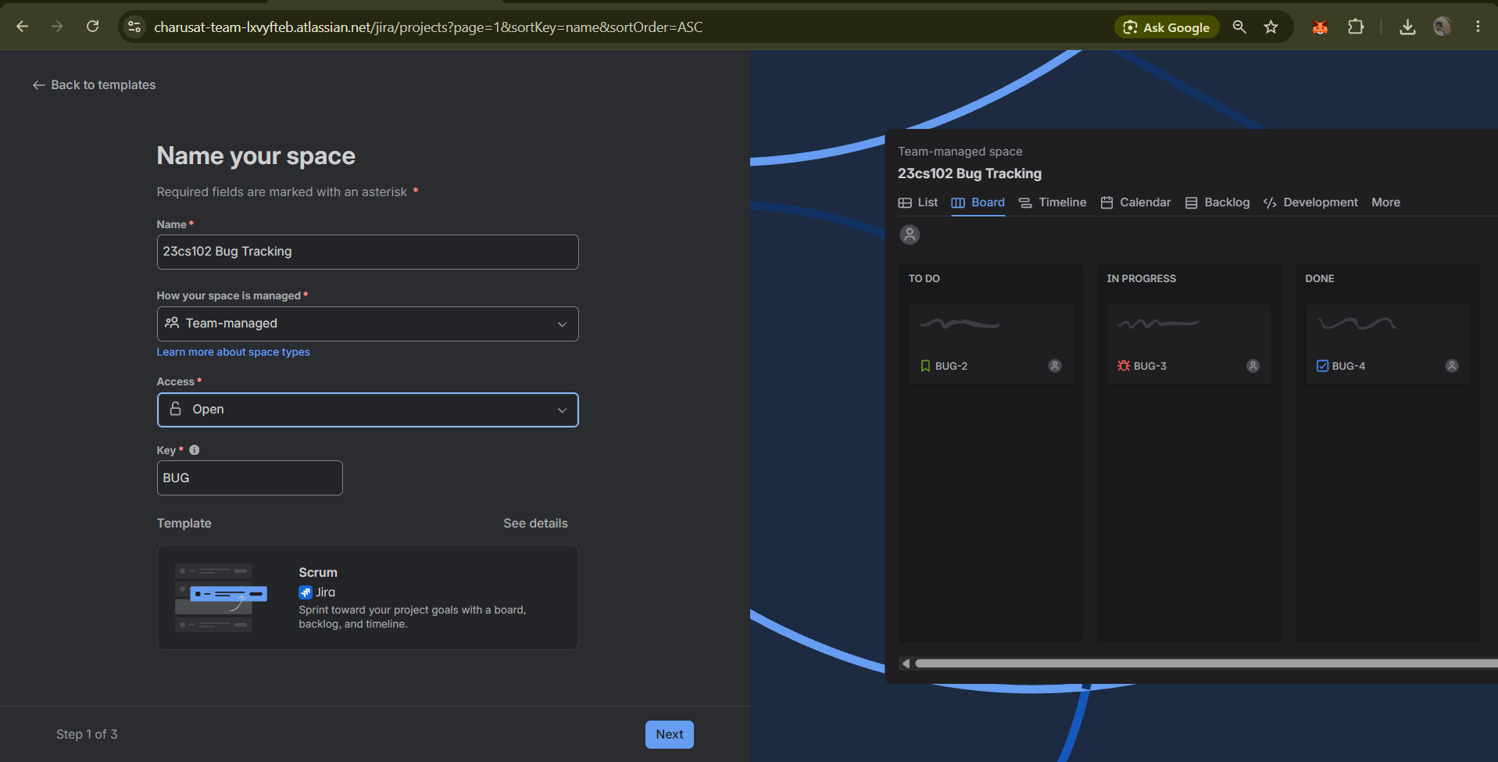
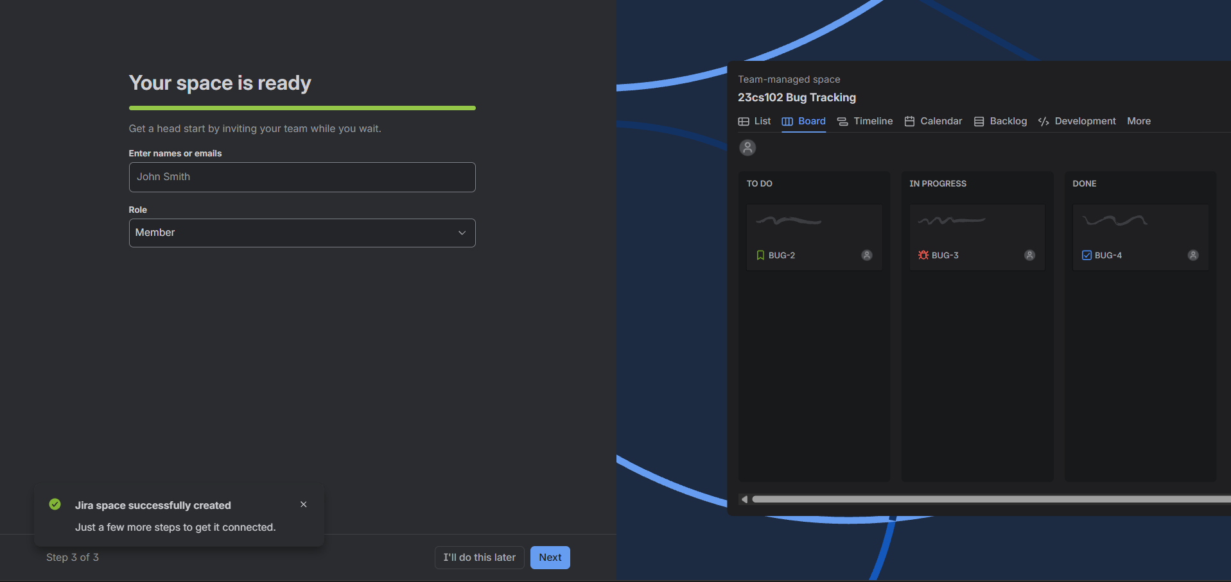

Step 2: Create Custom Issue Types
Create additional bug-related issue types if required.
- Go to Settings → Issues.
- Select Issue Types.
- Click Add Issue Type.
- Enter the Issue Type name.
- Save the configuration.
- Associate the Issue Type with the project scheme.

Step 3: Configure Bug Fields
Configure the fields required for bug reporting.
- Navigate to Screens.
- Create a new screen.
- Add the following fields:
  - Summary
  - Description
  - Priority
  - Assignee
  - Attachment
  - Labels
- Save the screen configuration.
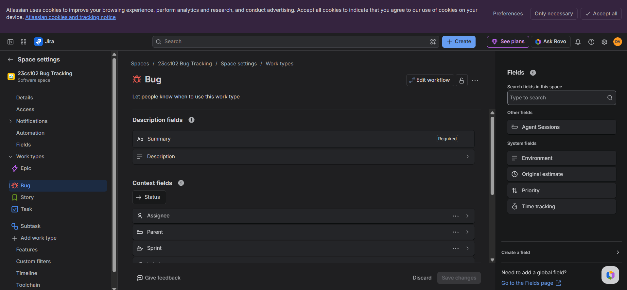

Step 4: Customize the Bug Workflow
Configure workflow stages for bug management.
- Open Project Settings.
- Select Workflows.
- Edit the existing workflow.
- Add the following statuses:
  - Open
  - Assigned
  - In Progress
  - Fixed
  - Testing
  - Verified
  - Closed
  - Reopened
- Create transitions between statuses.
- Publish the workflow.

Step 5: Create a Kanban/Scrum Board
Create a board to visualize bug progress.
- Click Boards → Create Board.
- Select Kanban Board or Scrum Board.
- Choose Board from Existing Project.
- Enter the board name.
- Associate it with the Bug Tracking project.
- Save the board.
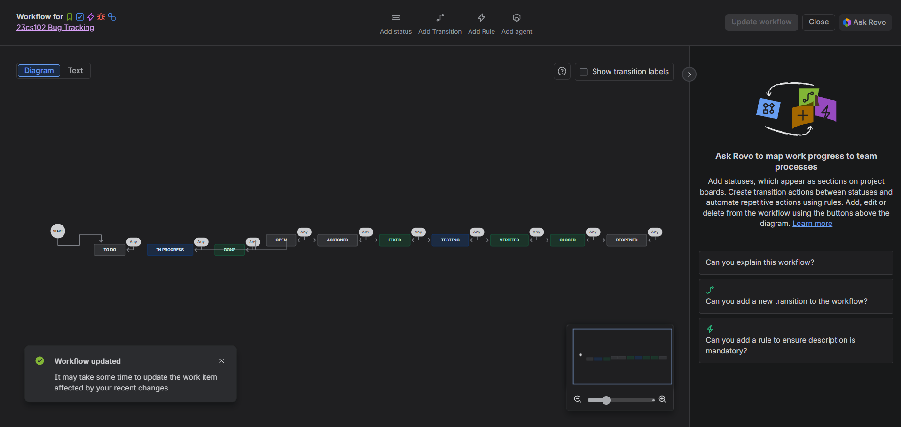
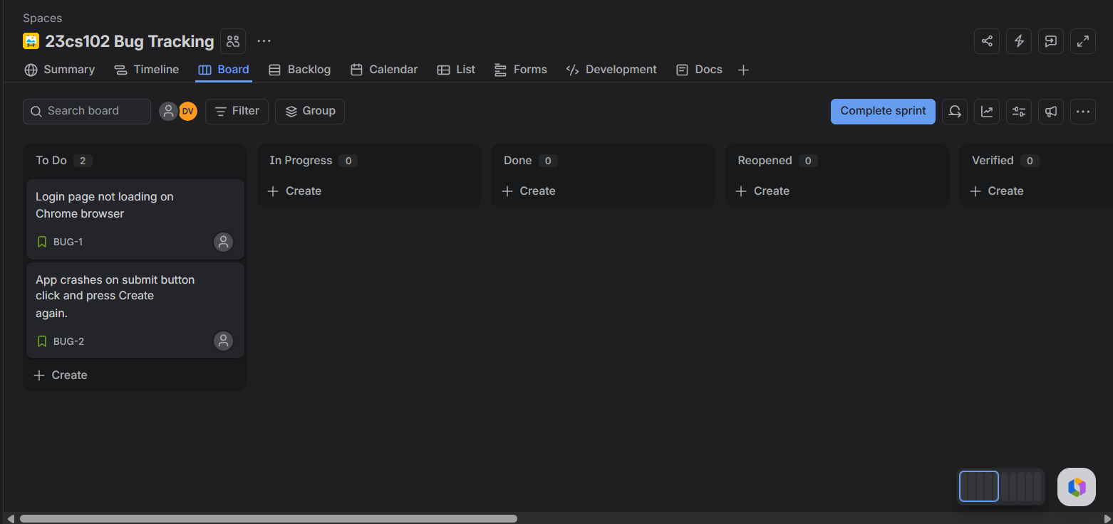

Step 6: Configure Bug Priorities
Define priority levels for bugs.
- Open Jira Settings → Issues → Priorities.
- Configure:
  - Highest
  - High
  - Medium
  - Low
  - Lowest
- Save the settings.
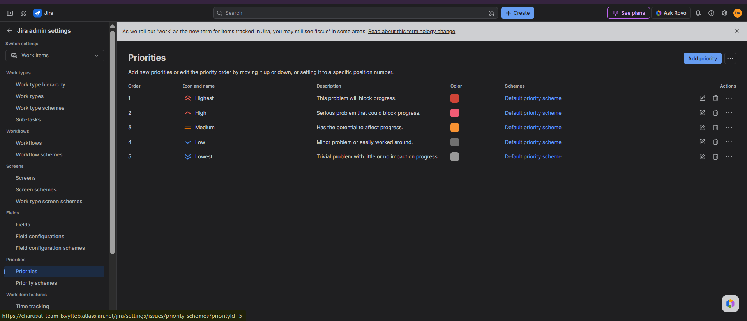

Step 7: Create a Bug Ticket
Create a new bug report.
- Click Create.
- Select Issue Type: Bug.
- Enter:
  - Summary
  - Description
  - Priority
  - Assignee
- Attach screenshots if available.
- Click Create.
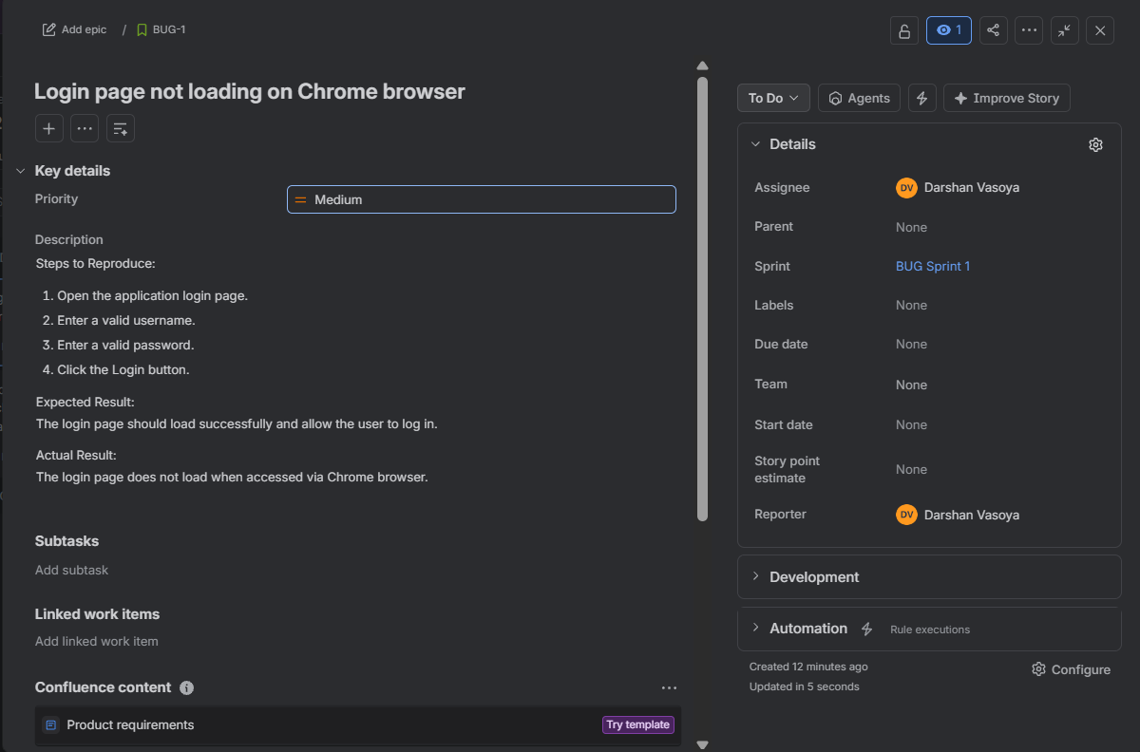

Step 8: Assign the Bug
Assign the reported bug to a developer.
- Open the created bug ticket.
- Select Assignee.
- Choose the responsible developer.
- Change status from Open to Assigned.

Step 9: Start Bug Fixing
Developer begins working on the defect.
- Open the assigned bug.
- Change status to In Progress.
- Investigate the issue.
- Implement the required fix.
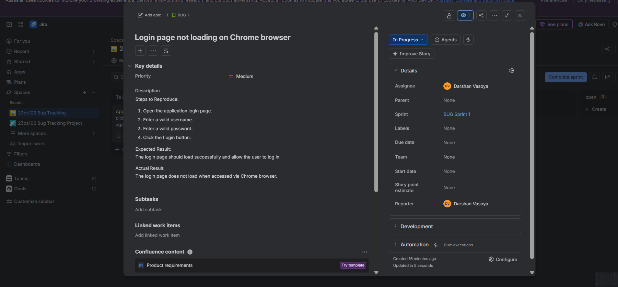

Step 10: Mark the Bug as Fixed
After implementing the solution:
- Update the ticket with fix details.
- Change status to Fixed.
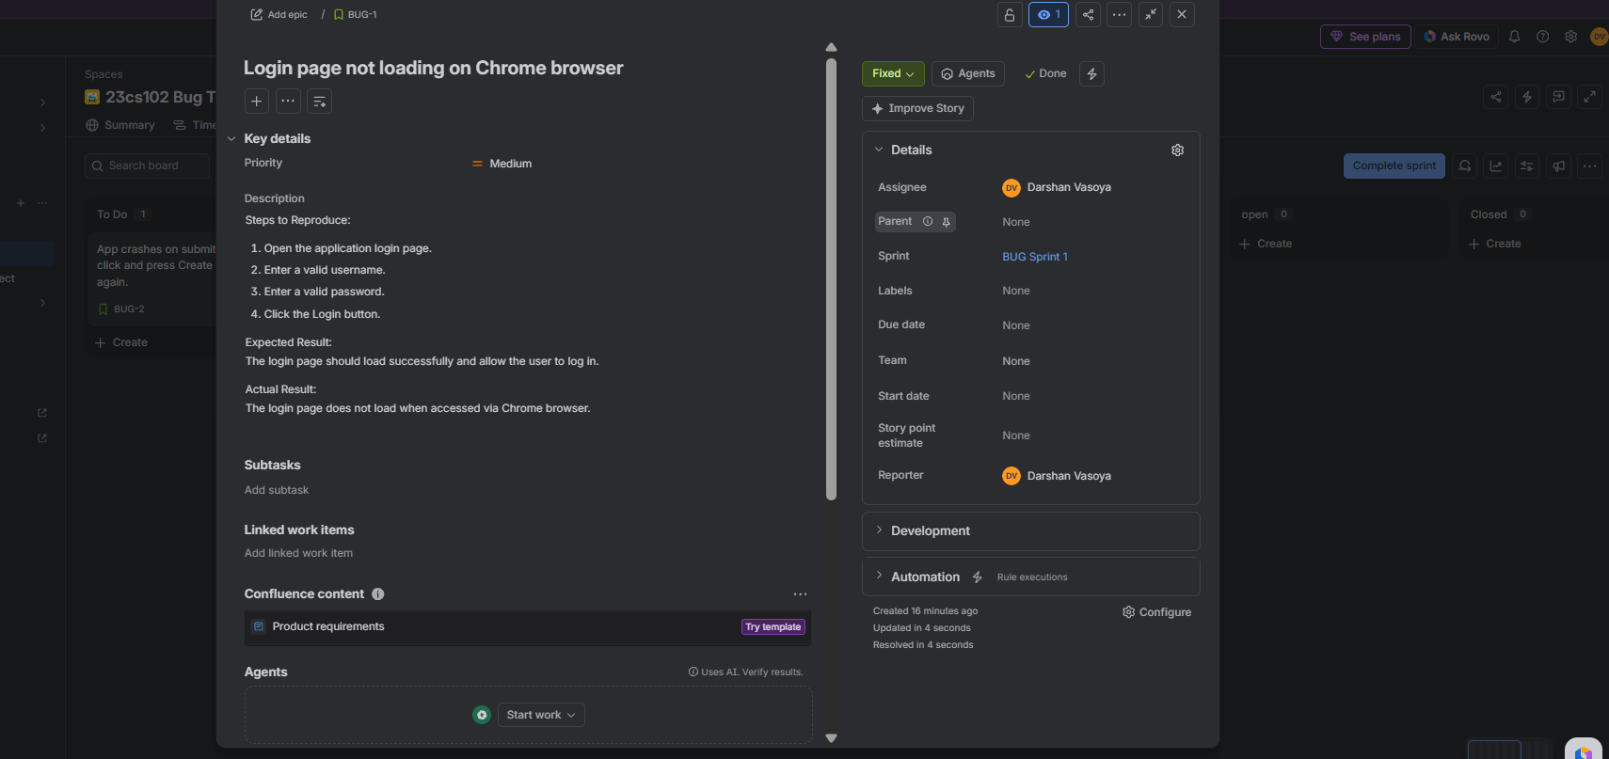

Step 11: Generate Bug Reports
Generate project reports for monitoring defects.
- Open Reports.
- Select Bug Summary Report.
- Configure filters.
- Generate and export the report.
